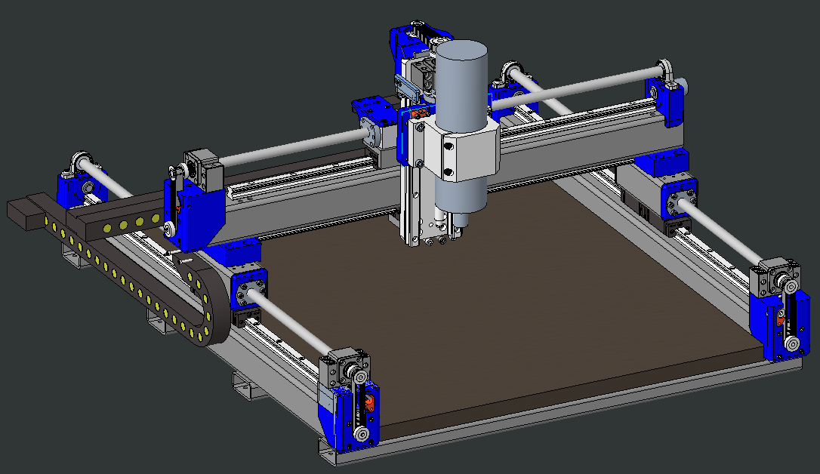

Found this cad online. The blue parts are intended to be printed and then replaced with aluminum.

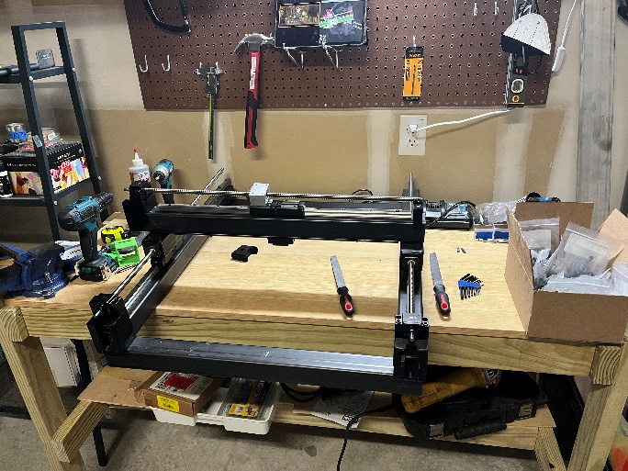

Here is the base frame screwed together. Not shown is this CNC on my kitchen countertop while my wife and I cooked dinner. It was on the countertop because it is the closest thing I have to a surface plate and I needed to shim the linear rails so that they were relatively flat.

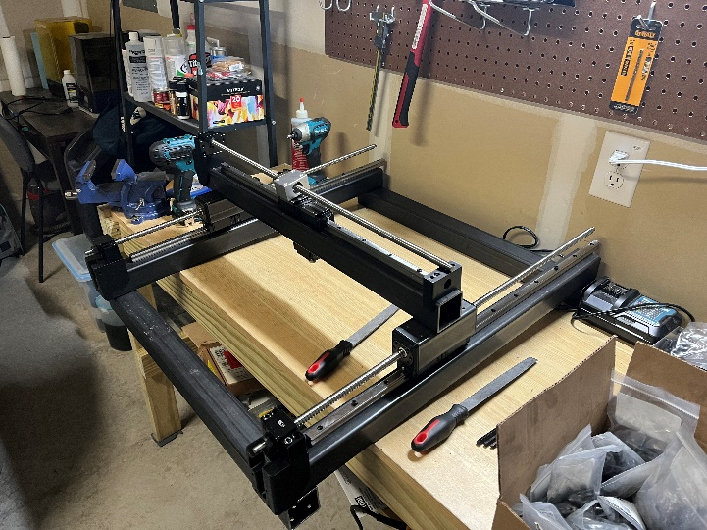

If you’ll take a closer look at the design, you’ll notice that the whole gantry system of this “3D printed” CNC machine is composed of bolted steel extrusions and linear rails with a relatively short path to ground. The 3D printed components are mainly motor mounts and other accessories, which shouldn’t have too much of an impact on the rigidity of the machine, especially when they are replaced with aluminum parts. This, in addition to the extremely parametric CAD is why I decided to make this machine instead of another.

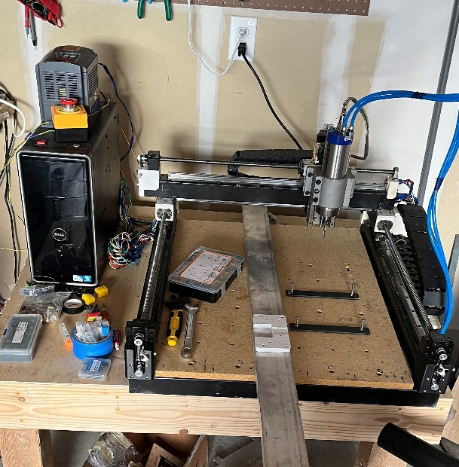

This is where we get to the bootstrapping part of the router. With the frame installed and electronics routed it is now time to start cutting aluminum! (I will not go into the wiring here. I do not want to re-live debugging why my electronics weren’t talking to each other. Apparently, things running on SPI protocol can’t have cables longer than a few mm long before the signal times out. I still don’t really know what SPI is, only that I really hate it.)

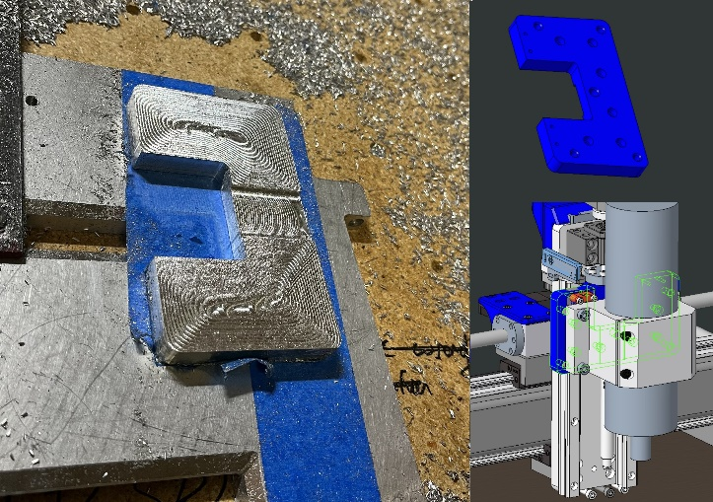

First cut down and it’s kind of crunchy. This is mainly because what I was making is the faceplate – the only “structural” 3D printed part in the piece, so once I got that done, the quality of my cuts went way up.

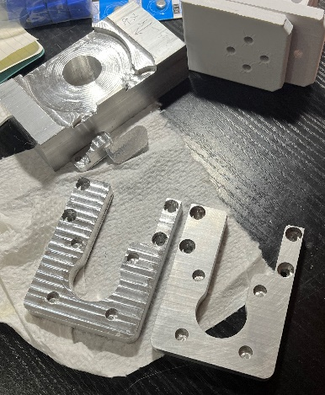

With the newly created faceplate installed I was able to breeze through rest of the aluminum parts for this machine. And with a little scotch-brite they look pretty good, if I do say so myself!

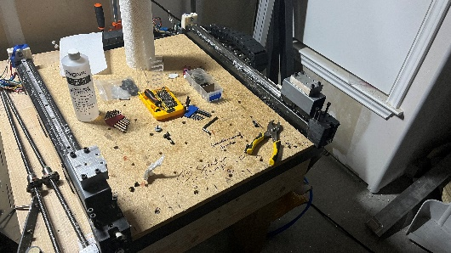

With the new parts made, it was time to take the machine apart and put them back together. The thin layer of grease and aluminum chips covering the machine made it much more fun to work with.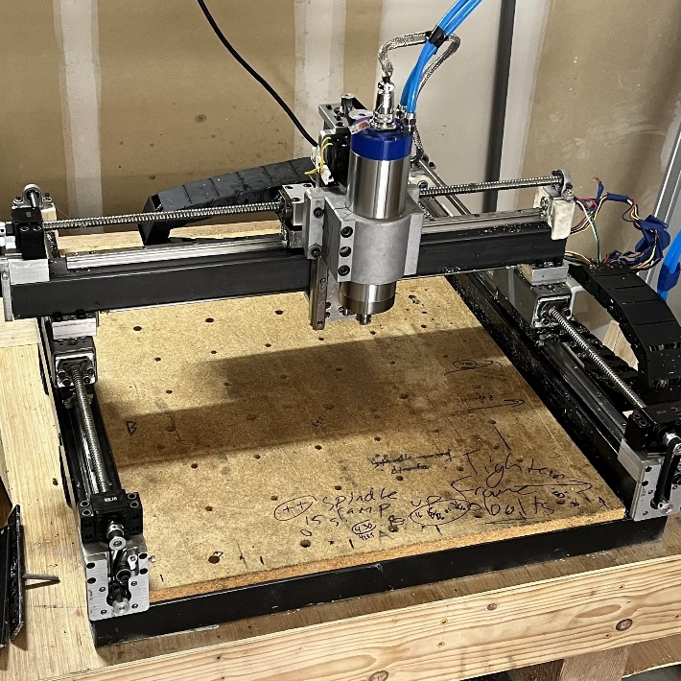

And there we have it! A mostly functional CNC router! There are still a million things I want to do to this thing, but I am going to leave it here for now and get working on other projects. Making tools is fun, but I don’t want to spend my whole life making the perfect CNC machine, only to realize that I’ve never made anything with it!